26.31: a) When the galvanometer reading is zero:
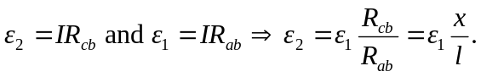
b) The value of the galvanometer’s resistance is unimportant since no current flows through it.
c) 